Linear Regression Complete Master Sheet
Complete notes covering definitions, formulas, metrics, assumptions, advantages, disadvantages, interview concepts, and visual diagrams.

1. Definition
Linear Regression is a supervised machine learning algorithm used to predict continuous numerical values using a best-fit straight line.

2. Core Formulas
Simple Linear Regression: ŷ = β₀ + β₁x
Multiple Linear Regression: ŷ = β₀ + β₁x₁ + β₂x₂ + ... + βₙxₙ
Residual: Residual = yᵢ - ŷᵢ
MSE: MSE = (1/n) Σ(yᵢ - ŷᵢ)²
MAE: MAE = (1/n) Σ|yᵢ - ŷᵢ|
RMSE: RMSE = √[(1/n) Σ(yᵢ - ŷᵢ)²]
R² Score: R² = 1 - (SSres / SStot)
Adjusted R²: Adj R² = 1 - ((1-R²)(N-1)/(N-P-1))
Gradient Descent: θ := θ - α ∂J(θ)/∂θ
VIF: VIF = 1 / (1 - R²)

3. Best Fit Line Visualization
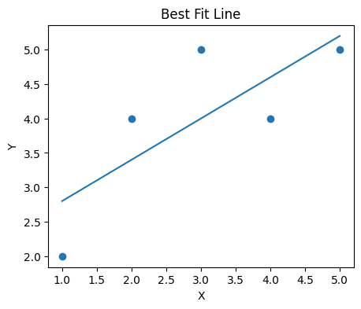

4. Residuals & Homoscedasticity
Residuals should have constant variance. Random spread around zero indicates homoscedasticity.
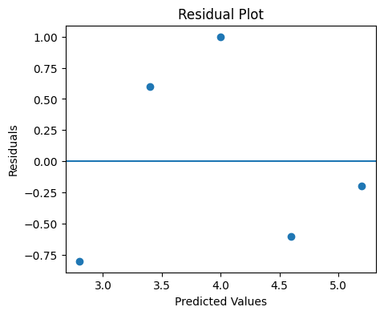

5. Assumptions
- Linear relationship
- No multicollinearity
- Homoscedasticity
- Normal distribution of residuals
- Independent observations

6. Advantages
- Simple and interpretable
- Fast training
- Works well for linear relationships
- Easy to implement

7. Disadvantages
- Sensitive to outliers
- Assumes linearity
- Cannot model complex patterns
- Affected by multicollinearity

8. Important Interview Questions
- Difference between MSE, MAE, and RMSE
- What is multicollinearity?
- What is homoscedasticity?
- Why use Adjusted R²?
- Difference between underfitting and overfitting

